**Computer Network Lab Exam Report**

**Objective:**

The objective of this exercise is to create and configure a suitable network topology for both LAN and WAN using 10-15 computers, routers, and switches. Additionally, the task involves simulating the transmission of a message from one network to a computer in another network using Cisco Packet Tracer.

**Procedure:**

**1. Topology Design:**

* **LAN Configuration**:
  + Design a network topology that includes at least 10 computers connected to switches.
* **WAN Configuration**:
  + Connect the LAN network to another network using routers.

**2. Network Setup in Cisco Packet Tracer:**

* **Add Devices**:
  1. Place and connect 10-15 computers.
  2. Add necessary switches (at least 2 for the LAN setup).
  3. Add at least 2 routers for the WAN setup.

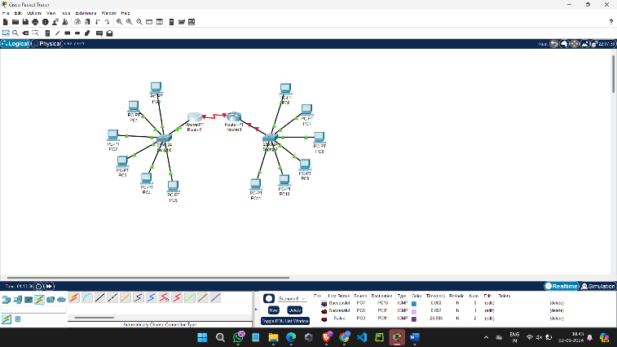

* **Configure IP Addresses**:
  1. Assign IP addresses to all computers within the LAN.
  2. Configure router interfaces with appropriate IP addresses.
  3. Set up routing protocols or static routes as needed for WAN communication.

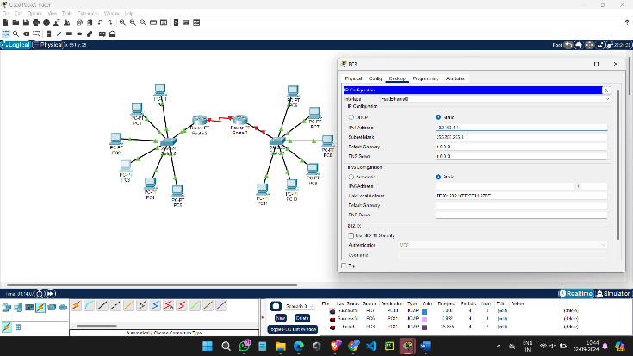

**3. Configuration Steps:**

* **LAN Configuration**:
  1. Connect computers to the switches.
  2. Configure IP addresses on each computer.
  3. Connect switches with each other as needed.
* **WAN Configuration**:
  1. Connect routers to each other.
  2. Configure router interfaces with IP addresses.
  3. Set up routing (static or dynamic) to ensure connectivity between the LANs.

**4. Simulation:**

* **Send a Message**:
  1. Use the simulation mode in Cisco Packet Tracer.
  2. Configure and send a message from a computer in one network to a computer in another network.
  3. Capture and verify the message transmission.

